VISVESVARAYA TECHNOLOGICAL UNIVERSITY
“JnanaSangama”, Belgaum -590014, Karnataka.

LAB REPORT
On

DATA STRUCTURES (23CS3PCDST)

Submitted by

Sahil Biswas (1BF24CS262)

in partial fulfillment for the award of the degree of
BACHELOR OF ENGINEERING
in
COMPUTER SCIENCE AND ENGINEERING



B.M.S. COLLEGE OF ENGINEERING
(Autonomous Institution under VTU)
BENGALURU-560019
August-December 2025

B. M. S. College of Engineering,
Bull Temple Road, Bangalore 560019
(Affiliated To Visvesvaraya Technological University, Belgaum)
Department of Computer Science and Engineering



This is to certify that the Lab work entitled “DATA STRUCTURES” carried out by Sahil Biswas (1BF24CS262), who is a bonafide student of B. M. S. College of Engineering. It is in partial fulfillment for the award of Bachelor of Engineering in Computer Science and Engineering of the Visvesvaraya Technological University, Belgaum during the year 2025-2026. The Lab report has been approved as it satisfies the academic requirements in respect of Data structures Lab - (23CS3PCDST) work prescribed for the said degree.

Anusha S Dr. Kavitha Sooda
Assistant Professor Professor and Head
Department of CSE Department of CSE
BMSCE, Bengaluru BMSCE, Bengaluru

Index Sheet
Sl.  No. | Experiment Title | Page No.
1 | Stack Operations
2 | Infix To Postfix Conversion Using Stack
3a  3b | Queue Operations  Circular Queue Operations
4a  4b | Singly Linked List Insertion Operations  Leetcode
5a  5b | Singly Linked List Deletion Operations  LeetCode
6a  6b | Reverse, Sort, Concatenation of linked lists  Stack, Queue Operation in linked list
7a  7b | Doubly Linked List Operations  LeetCode
8a  8b | Binary Search Tree Operations  LeetCode
9a  9b | BFS (BREADTH FIRST SEARCH)  DFS (DEPTH FIRST SEARCH)
10 | Design and develop a Program in C that uses Hash function

Course outcomes:
CO1 | Apply the concept of linear and nonlinear data structures.
CO2 | Analyze data structure operations for a given problem
CO3 | Design and develop solutions using the operations of linear and nonlinear data structure for a given specification.
CO4 | Conduct practical experiments for demonstrating the operations of different data structures.

Lab program 1:
Write a program to simulate the working of stack using an array with the following:
a) Push
b) Pop
c) Display
The program should print appropriate messages for stack overflow, stack underflow.
#include<stdio.h>
#define N 5

int stack[N];
int top = -1;
void push()
{
int x;
printf("Enter data:");
scanf("%d",&x);
if(top==N-1)
{
printf("Overflow\n");

}
else{
top++;
stack[top]=x;
}
}

void pop()
{
int item;
if(top==-1)
{
printf("Underflow\n");
}
else{
item=stack[top];
top--;
printf("Popped:%d\n",item);
}
}

void peek()
{
if(top==-1)
{
printf("Underflow\n");
}
else{
printf("Top element:%d\n",stack[top]);
}
}

void display()
{
if(top==-1)
{
printf("\nStack is empty\n");
}
else
{
int i;
printf("\nStack elements are:");
for(i=top; i>=0; i--)
{
printf("%d\n", stack[i]);
}
}
}

int main()
{
int choice;
while(1)
{
printf("\nStack Menu\n");
printf("1. Push\n");
printf("2. Pop\n");
printf("3. Peek\n");
printf("4. Display\n");
printf("5. Exit\n");
printf("Enter your choice:");
scanf("%d",&choice);

switch(choice)
{
case 1: push();
break;
case 2: pop();
break;
case 3: peek();
break;
case 4: display();
break;
case 5: return 0;
default: printf("Invalid choice\n");
}
}
return 0;
}

Output:
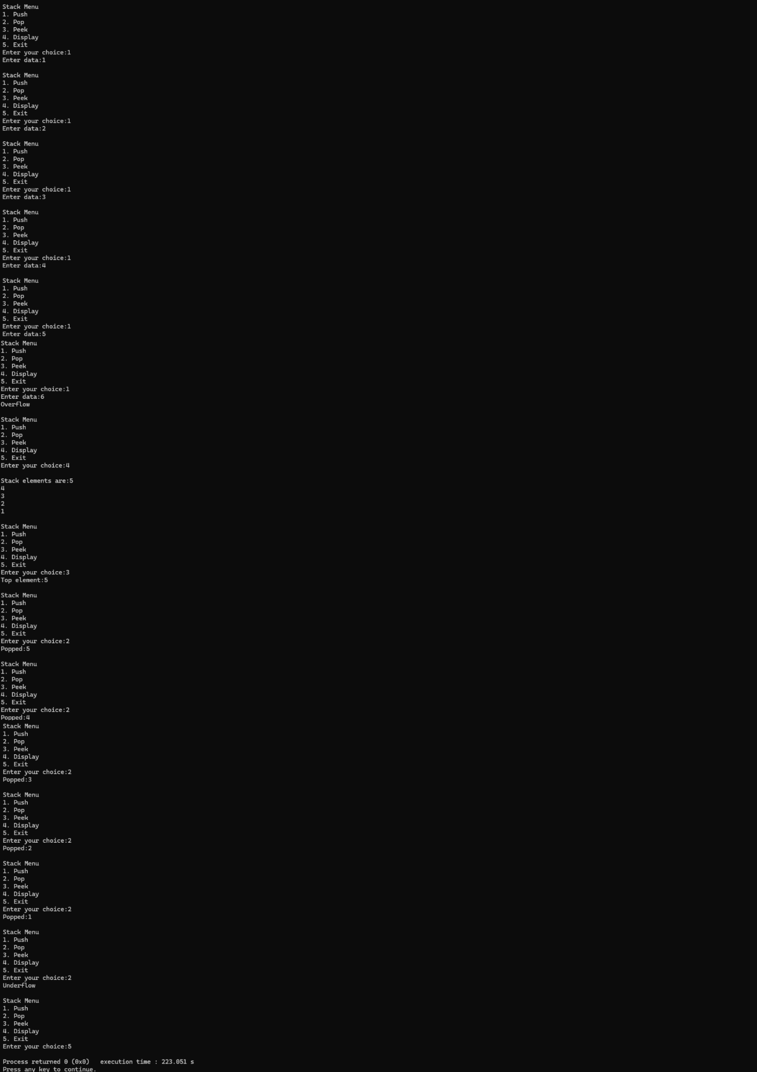

Lab program 2:
WAP to convert a given valid parenthesized infix arithmetic expression to postfix expression. The expression consists of single character operands and the binary operators + (plus), - (minus), * (multiply) and / (divide)
#include <stdio.h>
#include <ctype.h>
#include <string.h>

#define MAX 100
char stack[MAX];
int top=-1;

void push(char c)
{
if (top==MAX-1)
{
printf("Stack Overflow\n");
return;
}
stack[++top]=c;
}

char pop()
{
if (top==-1)
{
printf("Stack Underflow\n");
return -1;
}
return stack[top--];
}

char peek()
{
if (top==-1)
{
return -1;
}
return stack[top];
}

int precedence(char op)
{
switch(op)
{
case '+':
case '-':
return 1;
case '*':
case '/':
return 2;
case '^':
return 3;
case '(':
return 0;
}
return -1;
}

int associativity(char op)
{
if (op=='^')
{
return 1;
}
return 0;
}
void infixToPostfix(char infix[], char postfix[])
{
int i, k=0;
char c;

for(i=0; infix[i]!='\0'; i++)
{
c= infix[i];

if(isalnum(c))
{
postfix[k++]=c;
}
else if (c =='(')
{
push(c);
}
else if (c==')')
{
while (peek()!='(')
{
postfix[k++]=pop();
}
pop();
}
else
{
while(top!=-1 &&
((precedence(peek()) > precedence(c)) ||
(precedence(peek()) == precedence(c) &&
associativity(c) ==0)))
{
postfix[k++]=pop();
}
push(c);
}
}

while (top!=-1)
{
postfix[k++] = pop();
}
postfix[k]='\0';
}

int main()
{
char infix[MAX], postfix[MAX];

printf("Enter a valid parenthesized infix expression:");
scanf("%s", infix);

infixToPostfix(infix, postfix);

printf("Postfix expression: %s\n", postfix);

return 0;
}

Output:

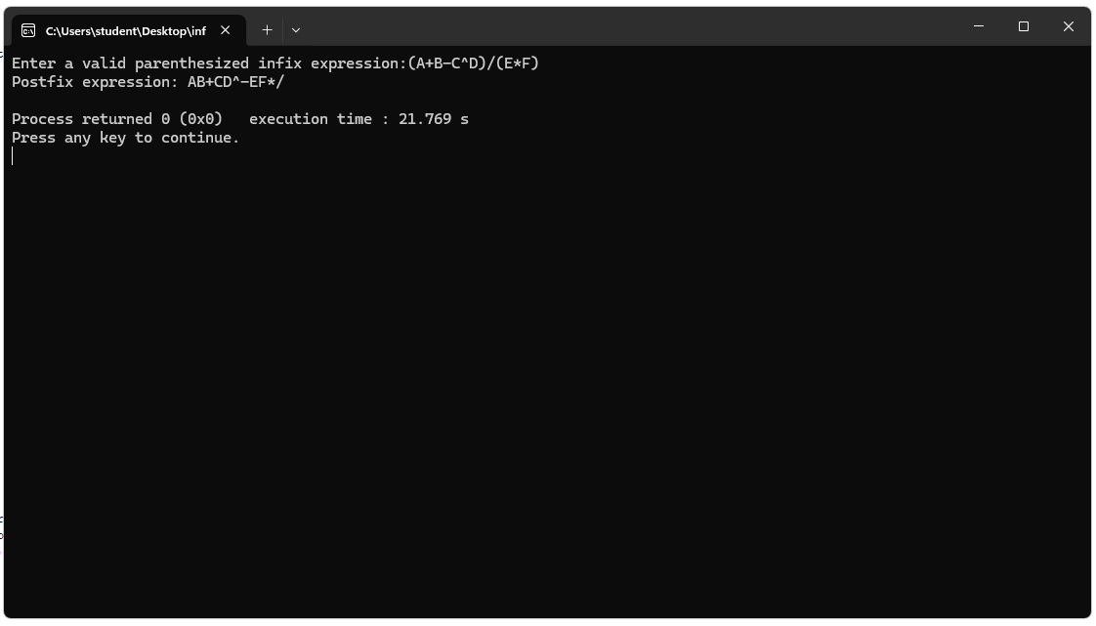

Lab program 3:
a) WAP to simulate the working of a queue of integers using an array. Provide the following operations: Insert, Delete, Display. The program should print appropriate messages for queue empty and queue overflow conditions
#include <stdio.h>
#define N 5

int queue[N];
int front = -1;
int rear = -1;

void enque(int x)
{
if (rear == N - 1)
{
printf("Queue Overflow (The Queue is full, cannot enter more elements)\n");
}
else if (front == -1 && rear == -1)
{
front = rear = 0;
queue[rear] = x;
}
else
{
rear++;
queue[rear] = x;
}
}

void deque()
{
if (front == -1 && rear == -1)
{
printf("Queue is empty, nothing to delete\n");
}
else if (front == rear)
{
printf("Deleted element: %d\n", queue[front]);
front = rear = -1;
}
else
{
printf("Deleted element: %d\n", queue[front]);
front++;
}
}

void display()
{
if (front == -1 && rear == -1)
{
printf("Queue is empty, nothing to display.\n");
}
else
{
printf("Queue elements: ");
for (int i = front; i <= rear; i++)
{
printf("%d ", queue[i]);
}
printf("\n");
}
}

int main()
{
int choice, value;
while (1)
{
printf("\nQueue Menu\n");
printf("1. Insert an element\n");
printf("2. Delete an element\n");
printf("3. Display the queue\n");
printf("4. Exit the program\n");
printf("Enter your choice: ");
scanf("%d", &choice);

switch (choice)
{
case 1:
printf("Enter the value to insert: ");
scanf("%d", &value);
enque(value);
break;
case 2:
deque();
break;
case 3:
display();
break;
case 4:
printf("You have exited the program.\nBye!\n");
return 0;
default:
printf("Invalid choice! Please select between 1 and 4.\n");
}
}
}
Output:
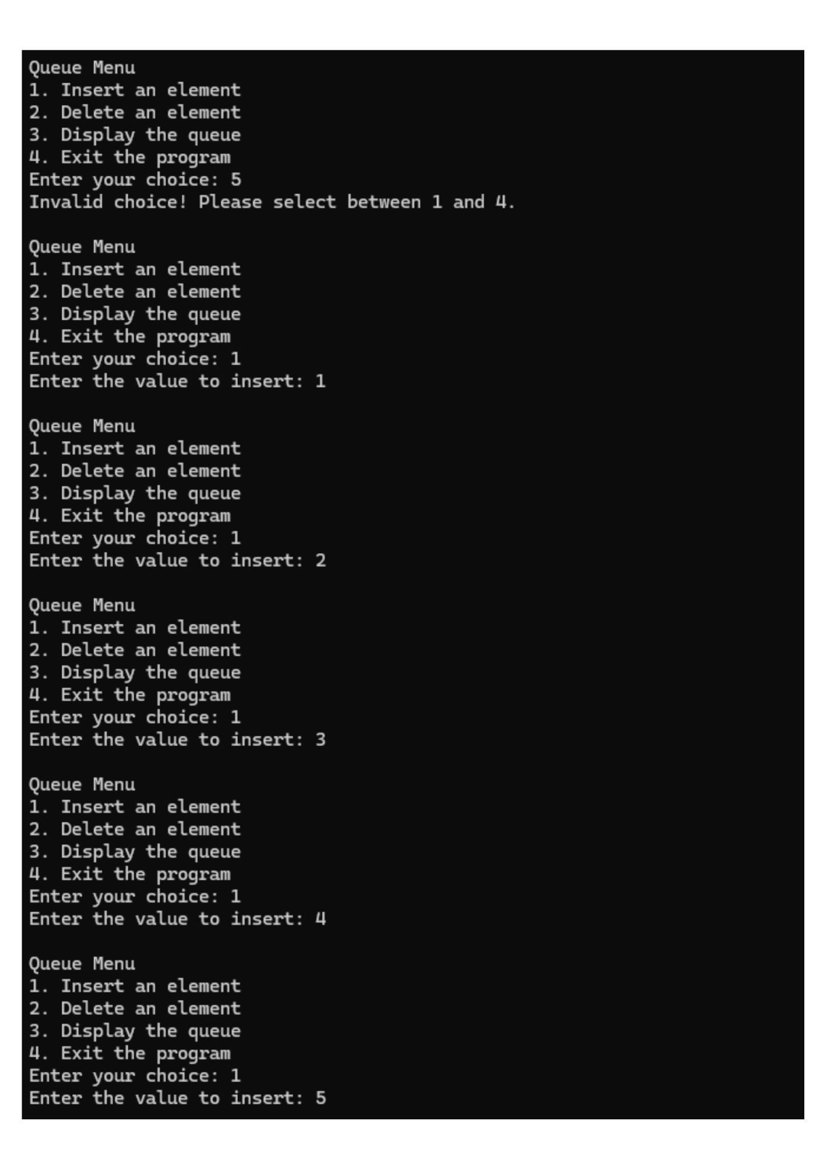

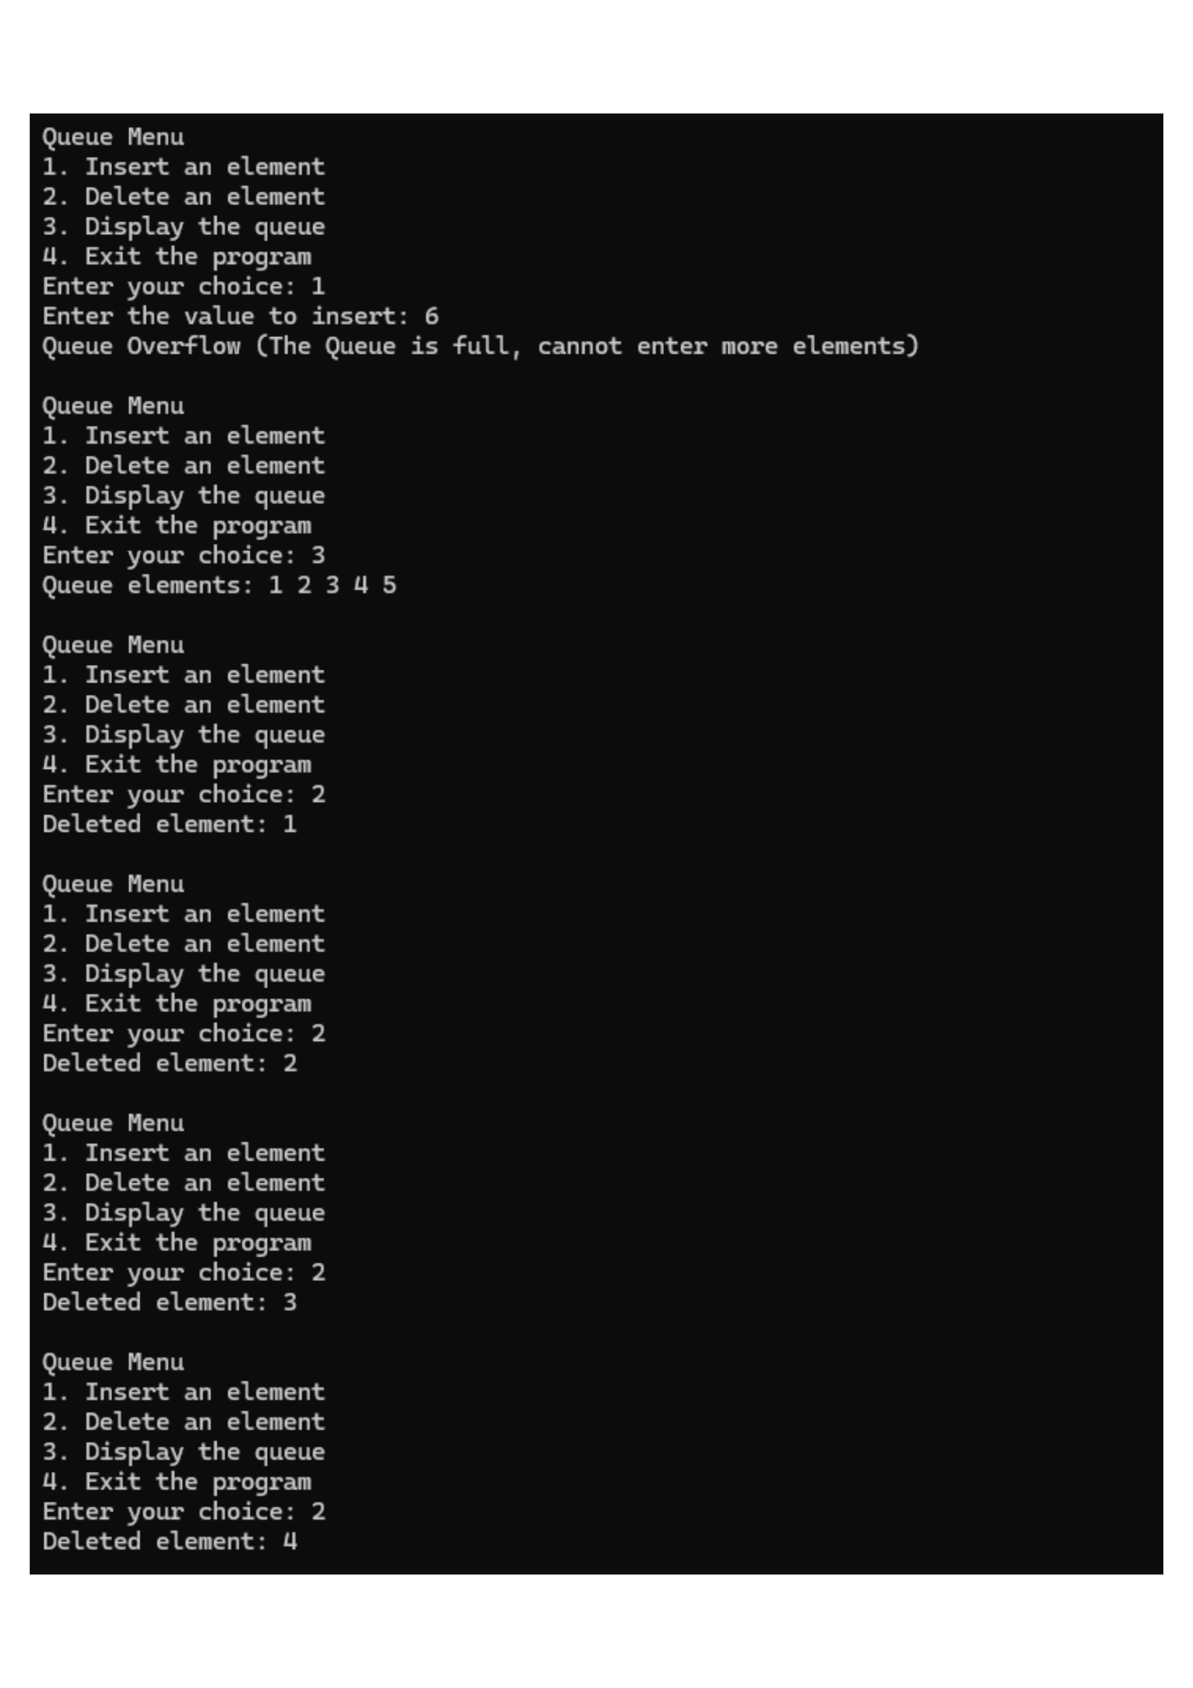

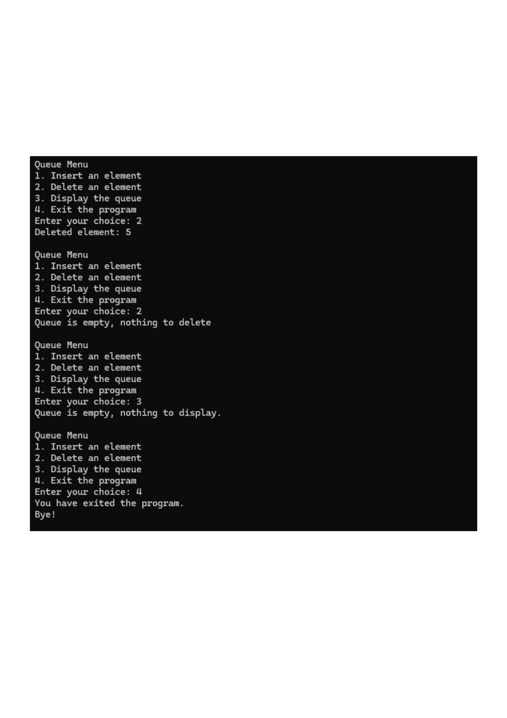

Lab program 3:
b ) WAP to simulate the working of a circular queue of integers using an array. Provide the following operations: Insert, Delete & Display. The program should print appropriate messages for queue empty and queue overflow conditions.
#include<stdio.h>
#define N 5

int queue[N];
int front = -1;
int rear = -1;

void enqueue(int x)
{
if (front == -1 && rear == -1)
{
front = rear = 0;
queue [rear] = x;
}
else if ((rear+1)%N == front)
{
printf("Queue is full, cannot enter more elements.");
}
else
{
rear = (rear+1)%N;
queue[rear] = x;
}
}

void dequeue()
{
if (front == -1 && rear == -1)
{
printf("Queue is empty, nothing to delete.");
}
else if (front == rear)
{
printf("Dequeued= %d\n", queue[front]);
front = rear = -1;
}
else
{
printf("Dequeued= %d\n", queue[front]);
front = (front +1)%N;
}
}

void display()
{
if (front == -1 && rear == -1)
{
printf("Queue is empty, nothing to display.\n");
}
else
{
printf("Queue elements: ");
if (front <= rear)
{
for (int i = front; i <= rear; i++)
printf("%d ", queue[i]);
}
else
{
for (int i = front; i < N; i++)
printf("%d ", queue[i]);
for (int i = 0; i <= rear; i++)
printf("%d ", queue[i]);
}
printf("\n");
}
}

int main()
{
int choice, value;
while(1)
{
printf("\nQueue Menu\n");
printf("1. Insert an element\n");
printf("2. Delete an element\n");
printf("3. Display the queue\n");
printf("4. Exit the program\n");
printf("Enter your choice:");
scanf("%d",&choice);

switch(choice)
{
case 1:
printf("Enter the value to insert:");
scanf("%d", &value);
enqueue(value);
break;
case 2:
dequeue();
break;
case 3:
display();
break;
case 4:
printf("You have exited the program.\nBye!\n");
return 0;
default:
printf("Invalid choice! Please select between 1 and 4\n");
}
}
}

Output:
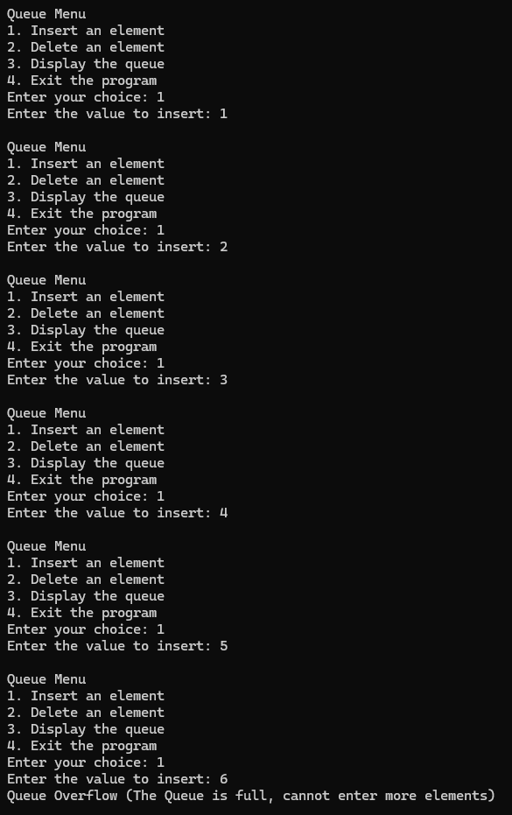
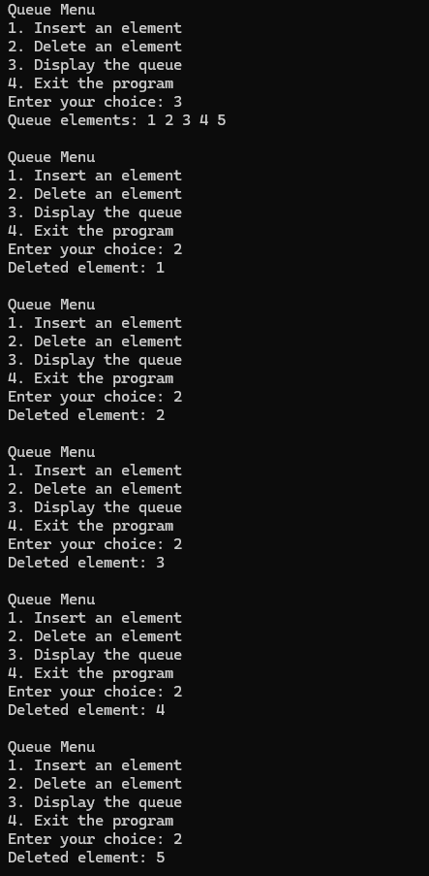

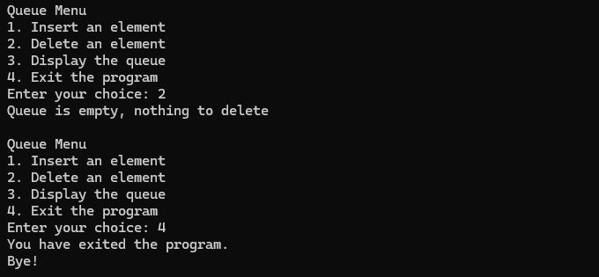

Lab program 4a:
WAP to Implement Singly Linked List with following operations
a) Create a linked list.
b) Insertion of a node at first position, at any position and at end of list.
Display the contents of the linked list.
Lab program 5a:
WAP to Implement Singly Linked List with following operations:
a) Create a linked list.
b) Deletion of first element, specified element and last element in the list.
c) Display the contents of the linked list.

#include <stdio.h>
#include <stdlib.h>

struct Node
{
int data;
struct Node *next;
};

struct Node *head = NULL;

void createList(int n)
{
struct Node *newNode, *temp;
int data, i;

if (n<= 0)
{
printf("Number of nodes should be greater than 0.\n");
return;
}

for (i=1;i<=n;i++)
{
newNode = (struct Node*)malloc(sizeof(struct Node));
if (newNode == NULL)
{
printf("Memory allocation failed.\n");
return;
}
printf("Enter data for node %d:", i);
scanf("%d", &data);
newNode->data=data;
newNode->next=NULL;

if (head == NULL)
{
head = newNode;
}
else
{
temp->next=newNode;
}
temp = newNode;
}

printf("\nLinked list created successfully.\n");
}

void insertAtBeginning(int data)
{
struct Node *newNode = (struct Node*)malloc(sizeof(struct Node));
newNode->data = data;
newNode->next = head;
head = newNode;
printf("Node inserted at the beginning.\n");
}

void insertAtEnd(int data)
{
struct Node *newNode = (struct Node*)malloc(sizeof(struct Node));
newNode->data = data;
newNode->next = NULL;

if (head == NULL)
{
head = newNode;
}
else
{
struct Node *temp = head;
while (temp->next !=NULL)
temp = temp->next;
temp->next = newNode;
}
printf("Node inserted at the end.\n");
}

void insertAtPosition(int data, int pos)
{
int i;
struct Node *newNode, *temp = head;

if (pos < 1)
{
printf("Invalid position.\n");
return;
}

if (pos == 1)
{
insertAtBeginning(data);
return;
}

newNode = (struct Node*)malloc(sizeof(struct Node));
newNode->data = data;

for (i=1; i<pos-1 && temp != NULL; i++)
temp = temp->next;

if (temp == NULL)
{
printf("Position out of range.\n");
free(newNode);
}
else
{
newNode->next = temp->next;
temp->next = newNode;
printf("Node inserted at position %d.\n", pos);
}
}

void displayList()
{
struct Node *temp = head;
if (head == NULL)
{
printf("List is empty.\n");
return;
}

printf("\nLinked List:");
while (temp!=NULL)
{
printf("%d ->", temp->data);
temp = temp->next;
}
printf("NULL\n");
}

void deleteFirst(){
struct Node *temp;
if (head == NULL){
printf("List is empty. Nothing to delete.\n");
return;
}
temp = head;
head = head->next;
printf("Deleted element: %d\n", temp->data);
free(temp);
}

void deleteLast(){
struct Node *temp, *prev;
if (head == NULL){
printf("List is empty. Nothing to delete.\n");
return;
}

if (head->next == NULL){
printf("Deleted element: %d\n", head->data);
free(head);
head = NULL;
return;
}

temp = head;
while (temp->next != NULL){
prev = temp;
temp = temp->next;
}
printf("Deleted element: %d\n", temp->data);
prev->next = NULL;
free(temp);
}

void deleteSpecific(int value){
struct Node *temp = head, *prev = NULL;

if (head == NULL){
printf("List is empty. Nothing to delete.\n");
return;
}

if (head->data == value){
head = head->next;
printf("Deleted element: %d\n", temp->data);
free(temp);
return;
}

while (temp != NULL && temp->data != value){
prev = temp;
temp = temp->next;
}

if (temp == NULL){
printf("Element %d not found in the list.\n", value);
return;
}

prev->next = temp->next;
printf("Deleted element:%d\n", temp->data);
free(temp);
}

int main()
{
int choice, n, data, pos;

while(1)
{
printf("\n--- Singly Linked List Operations ---\n");
printf("1. Create Linked List\n");
printf("2. Insert at Beginning\n");
printf("3. Insert at Any Position\n");
printf("4. Insert at End\n");
printf("5. Delete First Element\n");
printf("6. Delete Specific Element\n");
printf("7. Delete Last Element\n");
printf("8. Display List\n");
printf("9. Exit\n");
printf("Enter your choice:");
scanf("%d", &choice);

switch (choice)
{
case 1:
printf("Enter number of nodes: ");
scanf("%d", &n);
createList(n);
break;

case 2:
printf("Enter data to insert: ");
scanf("%d", &data);
insertAtBeginning(data);
break;

case 3:
printf("Enter data and position: ");
scanf("%d %d", &data, &pos);
insertAtPosition(data, pos);
break;

case 4:
printf("Enter data to insert: ");
scanf("%d", &data);
insertAtEnd(data);
break;

case 5:
deleteFirst();
break;

case 6:
printf("Enter value to delete: ");
scanf("%d", &data);
deleteSpecific(data);
break;

case 7:
deleteLast();
break;

case 8:
displayList();
break;

case 9:
printf("Exiting...\n");
exit(0);

default:
printf("Invalid choice. Try again.\n");
}
}
return 0;
}

Output:
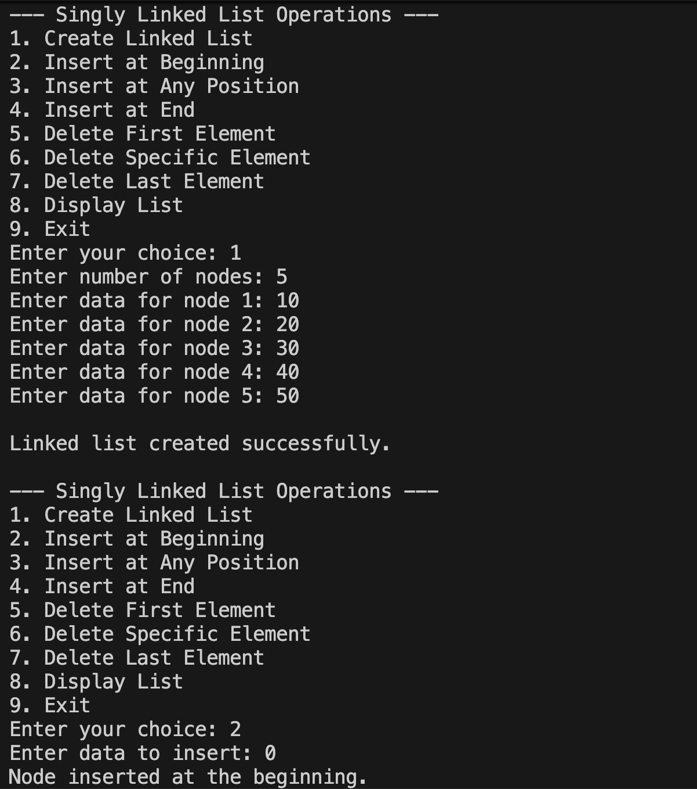
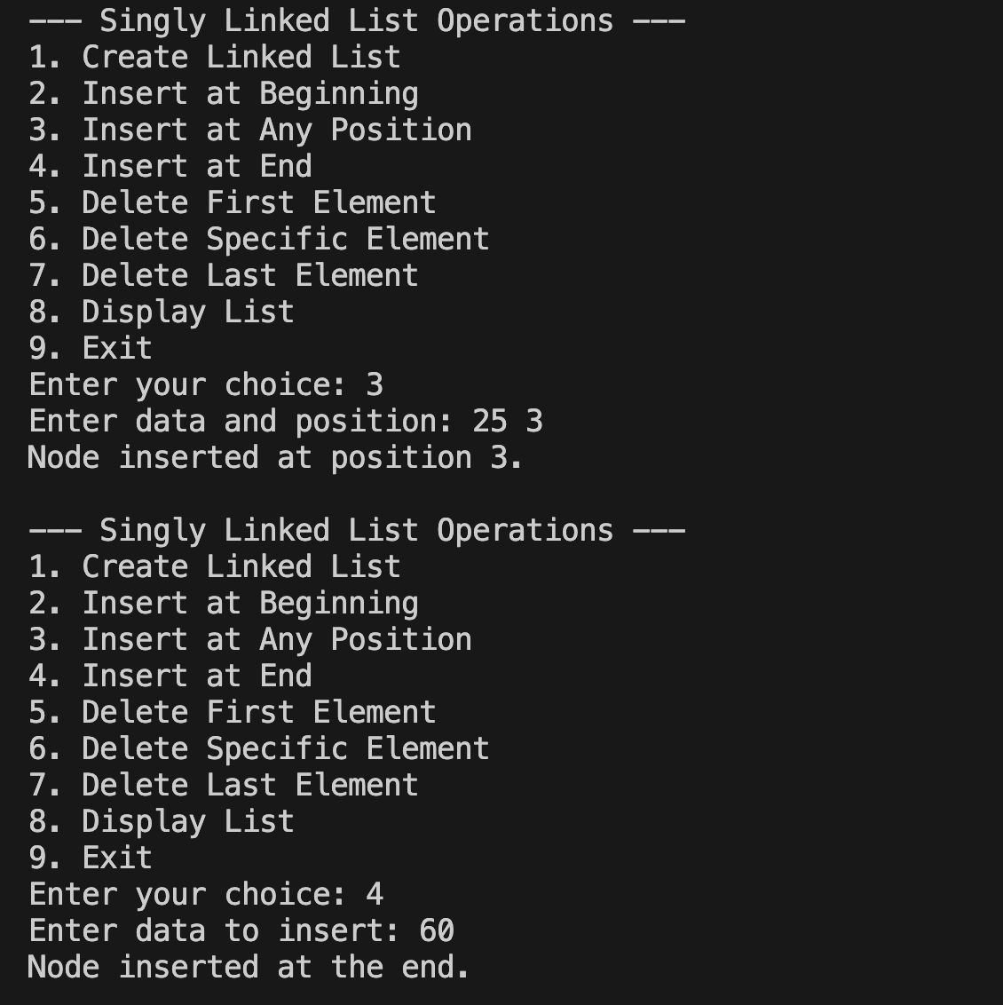
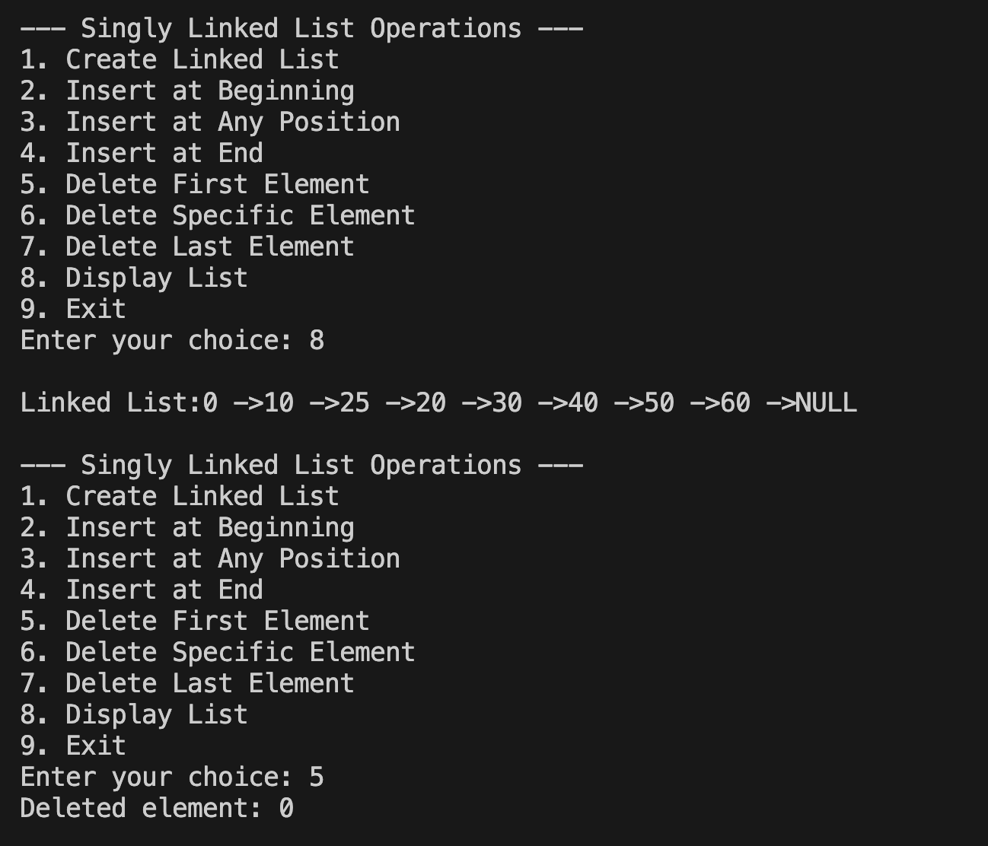
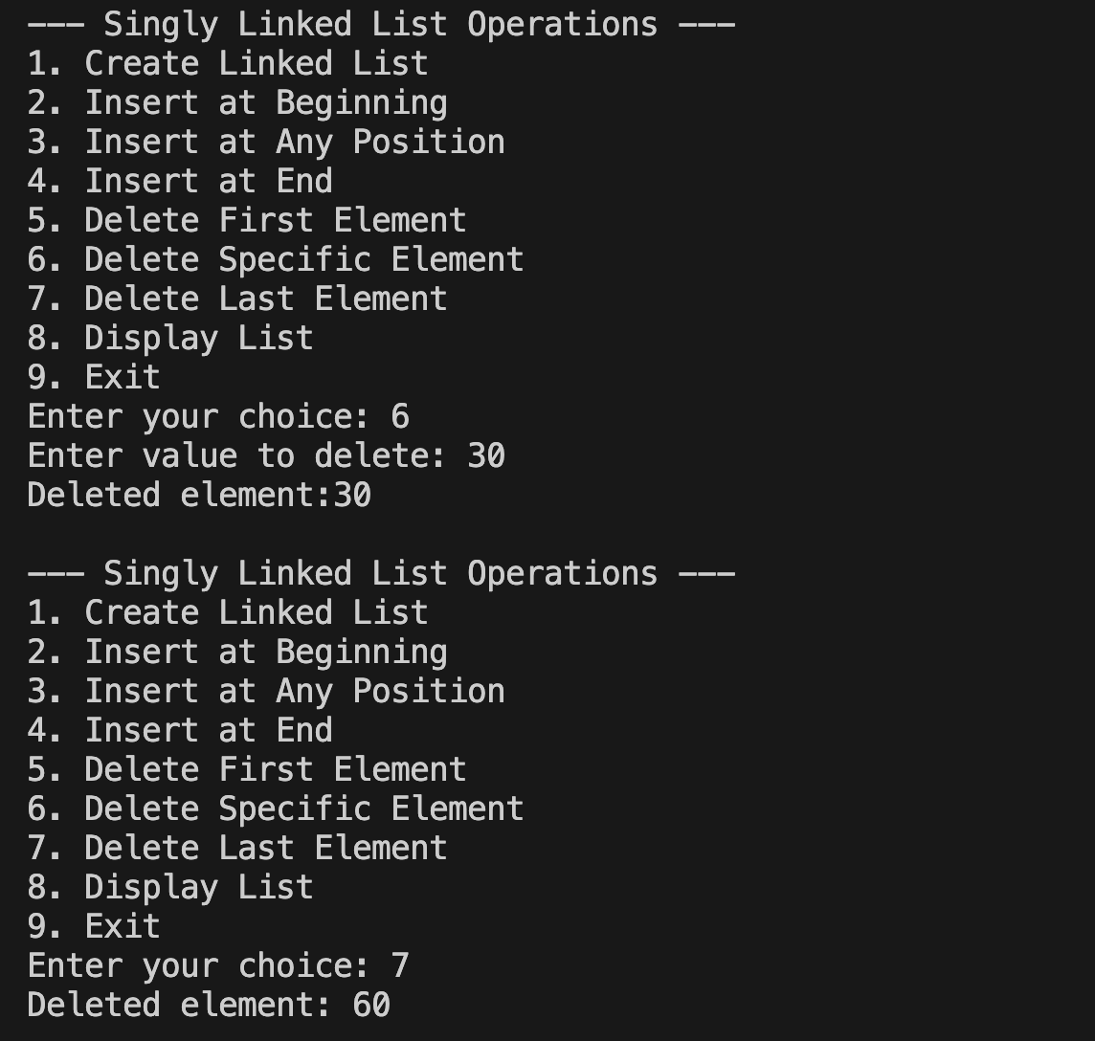
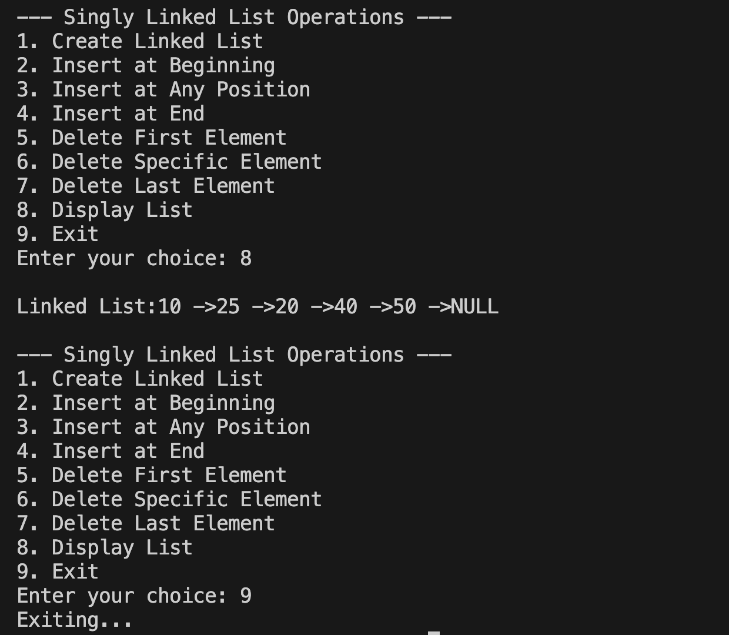

Lab program 4b:
Program - Leetcode platform

/**
* Definition for singly-linked list.
* struct ListNode {
* int val;
* struct ListNode *next;
* };
*/
struct ListNode* middleNode(struct ListNode* head) {
struct ListNode *slow = head;
struct ListNode *fast = head;

while (fast != NULL && fast->next != NULL) {
slow = slow->next; // move 1 step
fast = fast->next->next; // move 2 steps
}

return slow; // slow points to middle
}

Output:

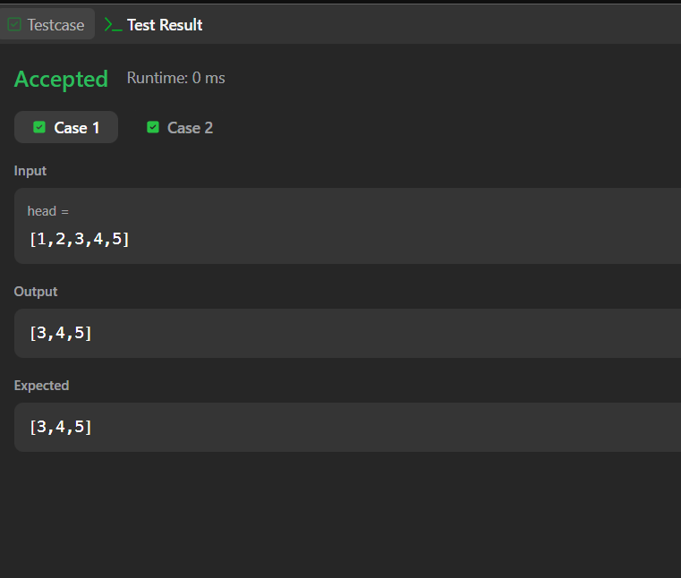

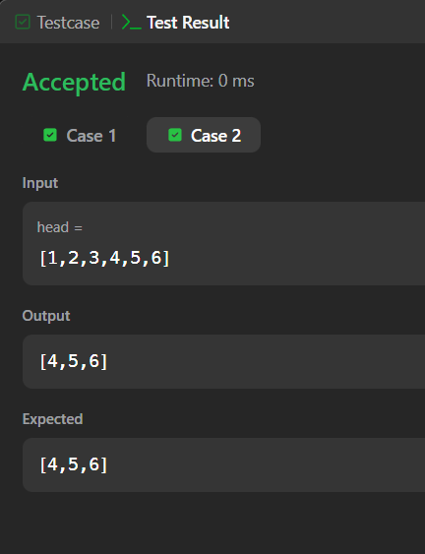

Lab program 5b:
Program - Leetcode platform
/**
* Definition for singly-linked list.
* struct ListNode {
* int val;
* struct ListNode *next;
* };
*/
struct ListNode* removeElements(struct ListNode* head, int val)
{
// Create a dummy node
struct ListNode dummy;
dummy.next = head;

struct ListNode* prev = &dummy;
struct ListNode* curr = head;

while (curr != NULL)
{
if (curr->val == val)
{
prev->next = curr->next; // remove current node
}
else
{
prev = curr; // move prev forward
}
curr = curr->next;
}

return dummy.next;
}

Output:
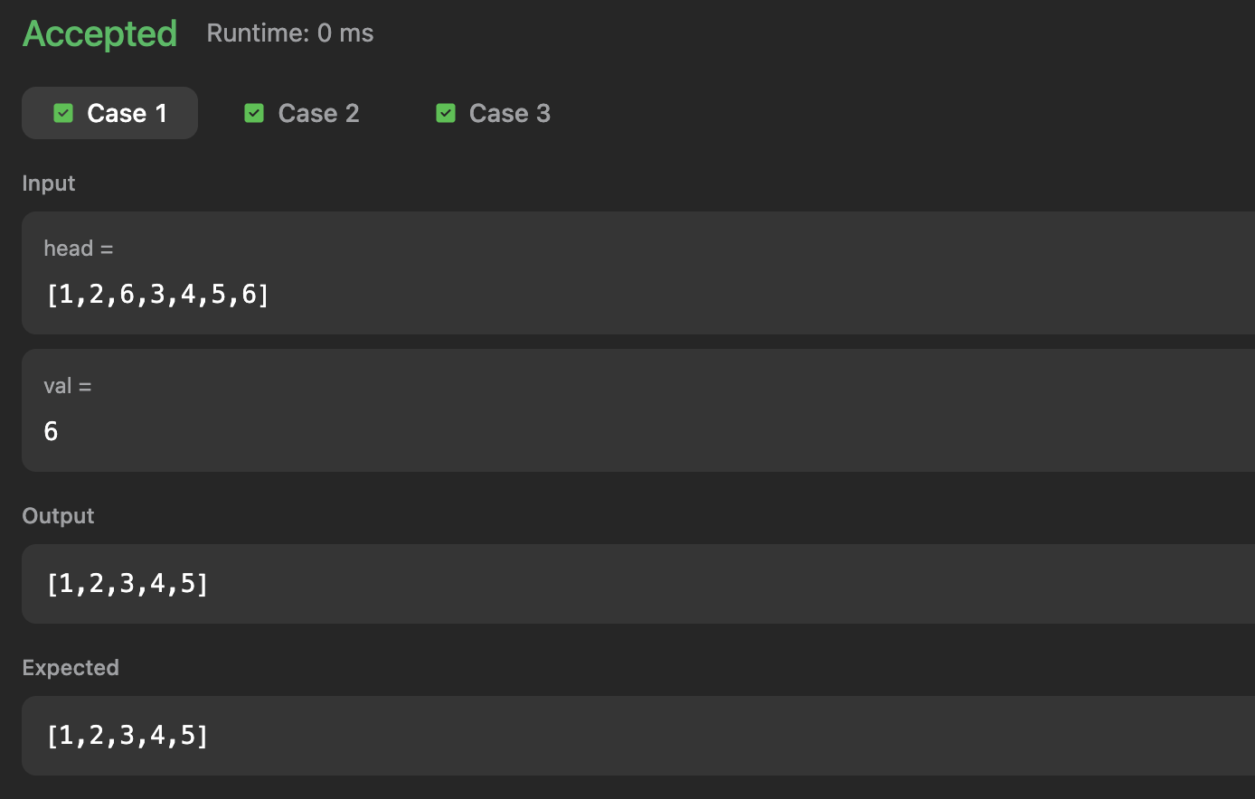

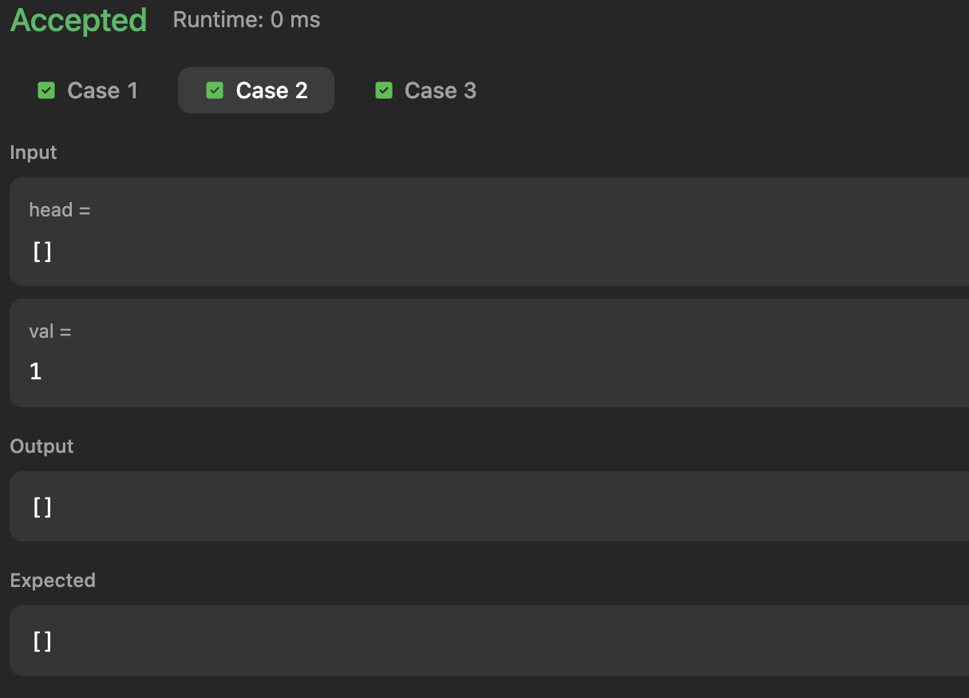
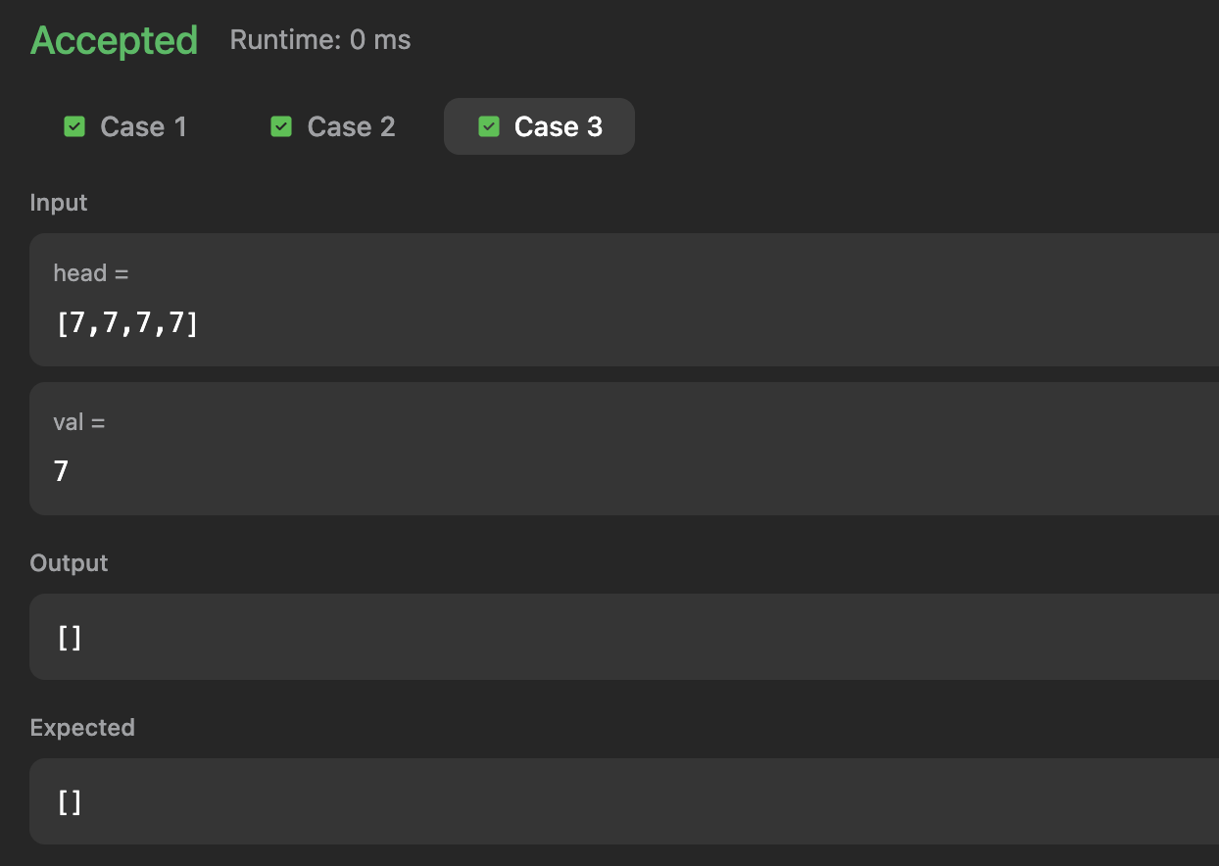

Lab program 6a:
a) WAP to Implement Single Link List with following operations: Sort the linked list, Reverse the linked list, Concatenation of two linked lists.
#include<stdio.h>
#include<stdlib.h>

struct Node{
int data;
struct Node *next;
};

struct Node *head1 = NULL, *head2 = NULL;

struct Node* createList(int n){
struct Node *head = NULL, *newNode, *temp;
int data, i;

for (i = 1; i<= n; i++){
newNode = (struct Node*)malloc(sizeof(struct Node));
if (newNode == NULL) {
printf("Memory allocation failed.\n");
exit(0);
}

printf("Enter data for node %d: ",i);
scanf("%d", &data);
newNode->data = data;
newNode->next = NULL;

if (head == NULL)
head = newNode;
else
temp->next = newNode;

temp = newNode;
}

printf("Linked list created successfully.\n");
return head;
}

void displayList(struct Node *head) {
if (head == NULL){
printf("List is empty.\n");
return;
}
struct Node *temp = head;
while (temp != NULL){
printf("%d ->", temp->data);
temp = temp->next;
}
printf("Null\n");
}

void sortList(struct Node *head){
struct Node *i, *j;
int tempData;

if (head == NULL){
printf("List is empty. Nothing to sort.\n");
return;
}

for (i = head; i-> next != NULL; i = i->next){
for (j = i->next; j != NULL; j = j->next){
if (i->data > j->data){
tempData = i->data;
i->data = j->data;
j->data = tempData;
}
}
}
printf("Linked list sorted successfully.\n");
}

struct Node* reverseList(struct Node *head) {
struct Node *prev = NULL, *curr = head, *next = NULL;

while (curr != NULL) {
next = curr->next;
curr->next = prev;
prev = curr;
curr = next;
}

printf("Linked list reversed successfully.\n");
return prev;
}

struct Node* concatenate(struct Node *head1, struct Node *head2){
struct Node *temp;

if (head1 == NULL) return head2;
if (head2 == NULL) return head1;

temp = head1;
while (temp->next != NULL)
temp = temp->next;

temp->next = head2;

printf("Linked lists concatenated successfully.\n");
return head1;
}

int main() {
int choice, n1, n2;
while (1){
printf("\n--- Singly Linked List Operations ---\n");
printf("1. Create First Linked List\n");
printf("2. Create Second Linked List\n");
printf("3. Display First List\n");
printf("4. Display Second List\n");
printf("5. Sort First List\n");
printf("6. Reverse First List\n");
printf("7. Concatenate Two Lists\n");
printf("8. Display Concatenated List\n");
printf("9. Exit\n");
printf("Enter your choice: ");
scanf("%d", &choice);

switch (choice) {

case 1:
printf("Enter number of nodes for first list: ");
scanf("%d", &n1);
head1 = createList(n1);
break;

case 2:
printf("Enter number of nodes for second list: ");
scanf("%d", &n2);
head2 = createList(n2);
break;

case 3:
printf("First Linked List: ");
displayList(head1);
break;

case 4:
printf("Second Linked List: ");
displayList(head2);
break;

case 5:
sortList(head1);
break;

case 6:
head1 = reverseList(head1);
break;

case 7:
head1 = concatenate(head1, head2);
head2 = NULL;
break;

case 8:
printf("Concatenated Linked List: ");
displayList(head1);
break;

case 9:
printf("Exiting program.\n");
exit(0);

default:
printf("Invalid choice! Please try again.\n");
}
}

return 0;
}

Output:
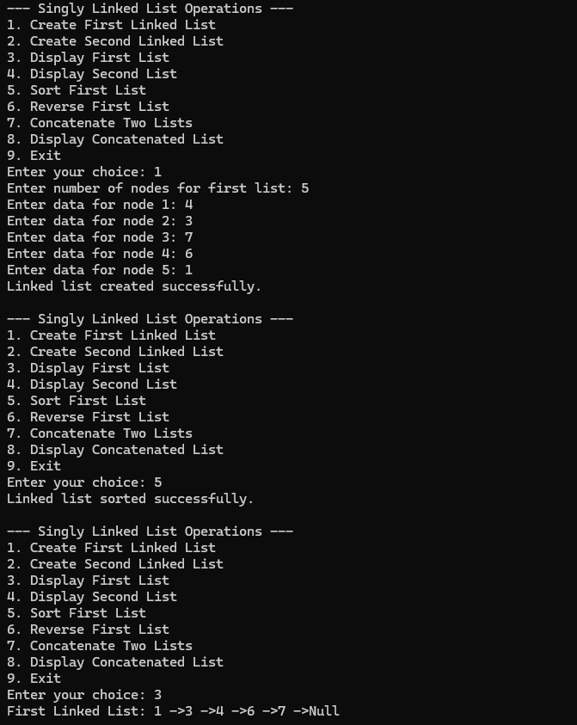
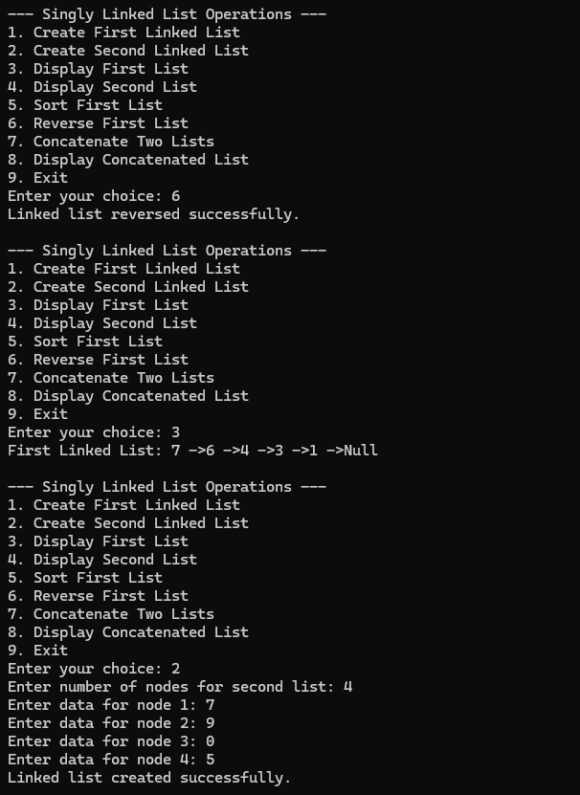
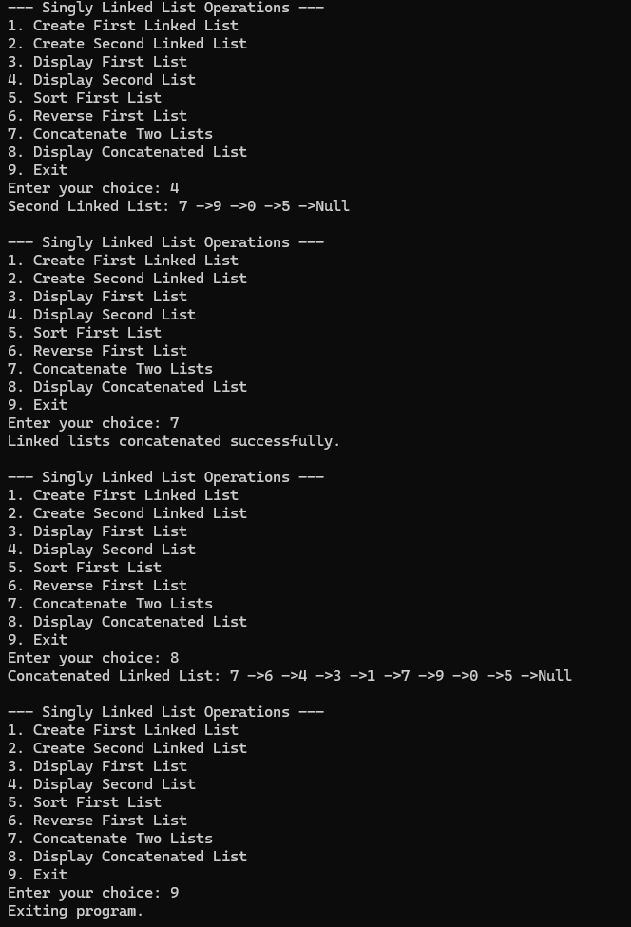

Lab program 6b:
WAP to Implement Single Link List to simulate Stack & Queue Operations.
#include <stdio.h>
#include <stdlib.h>

struct Node {
int data;
struct Node *next;
};

struct Node *top = NULL; // For Stack
struct Node *front = NULL; // For Queue
struct Node *rear = NULL; // For Queue

// Function to create a new node
struct Node* createNode(int value) {
struct Node *newNode = (struct Node*)malloc(sizeof(struct Node));
if (!newNode) {
printf("Memory allocation failed!\n");
exit(0);
}
newNode->data = value;
newNode->next = NULL;
return newNode;
}

/*------------------ STACK OPERATIONS ------------------*/

// PUSH operation (insert at beginning)
void push(int value) {
struct Node *newNode = createNode(value);
newNode->next = top;
top = newNode;
printf("%d pushed onto the stack.\n", value);
}

// POP operation (delete from beginning)
void pop() {
if (top == NULL) {
printf("Stack is empty. Nothing to pop.\n");
return;
}
struct Node *temp = top;
printf("%d popped from the stack.\n", top->data);
top = top->next;
free(temp);
}

// DISPLAY Stack
void displayStack() {
struct Node *temp = top;
if (temp == NULL) {
printf("Stack is empty.\n");
return;
}
printf("Stack (Top to Bottom): ");
while (temp != NULL) {
printf("%d ", temp->data);
temp = temp->next;
}
printf("\n");
}

/*------------------ QUEUE OPERATIONS ------------------*/

// ENQUEUE operation (insert at end)
void enqueue(int value) {
struct Node *newNode = createNode(value);
if (rear == NULL) {
front = rear = newNode;
} else {
rear->next = newNode;
rear = newNode;
}
printf("%d enqueued to the queue.\n", value);
}

// DEQUEUE operation (delete from front)
void dequeue() {
if (front == NULL) {
printf("Queue is empty. Nothing to dequeue.\n");
return;
}

struct Node *temp = front;
printf("%d dequeued from the queue.\n", front->data);
front = front->next;

if (front == NULL) // if queue becomes empty
rear = NULL;

free(temp);
}

// DISPLAY Queue
void displayQueue() {
struct Node *temp = front;
if (temp == NULL) {
printf("Queue is empty.\n");
return;
}
printf("Queue (Front to Rear): ");
while (temp != NULL) {
printf("%d ", temp->data);
temp = temp->next;
}
printf("\n");
}

/* ------------------- MAIN MENU ------------------- */
int main() {
int choice, value, ch;

while (1) {
printf("\n--- Singly Linked List Simulation ---\n");
printf("1. Stack Operations\n");
printf("2. Queue Operations\n");
printf("3. Exit\n");
printf("Enter your choice: ");
scanf("%d", &choice);

switch (choice) {
case 1:
while (1) {
printf("\n--- Stack Menu ---\n");
printf("1. Push\n");
printf("2. Pop\n");
printf("3. Display Stack\n");
printf("4. Back to Main Menu\n");
printf("Enter your choice: ");
scanf("%d", &ch);

switch (ch) {
case 1:
printf("Enter value to push: ");
scanf("%d", &value);
push(value);
break;
case 2:
pop();
break;
case 3:
displayStack();
break;
case 4:
break;
default:
printf("Invalid choice.\n");
}

if (ch == 4) break; // Exit the Stack menu and go back to Main Menu
}
break;

case 2:
while (1) {
printf("\n--- Queue Menu ---\n");
printf("1. Enqueue\n");
printf("2. Dequeue\n");
printf("3. Display Queue\n");
printf("4. Back to Main Menu\n");
printf("Enter your choice: ");
scanf("%d", &ch);

switch (ch) {
case 1:
printf("Enter value to enqueue: ");
scanf("%d", &value);
enqueue(value);
break;
case 2:
dequeue();
break;
case 3:
displayQueue();
break;
case 4:
break;
default:
printf("Invalid choice.\n");
}

if (ch == 4) break; // Exit the Queue menu and go back to Main Menu
}
break;

case 3:
printf("Exiting program.\n");
exit(0);

default:
printf("Invalid choice. Try again.\n");
}
}

return 0;
}

Output:
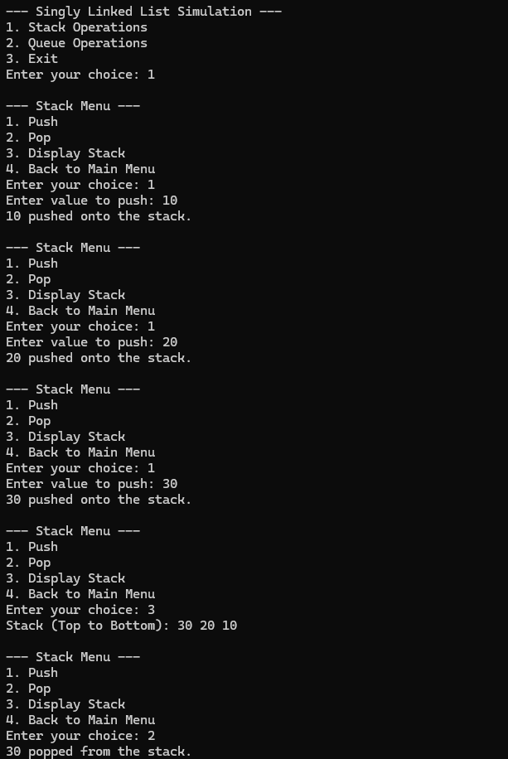
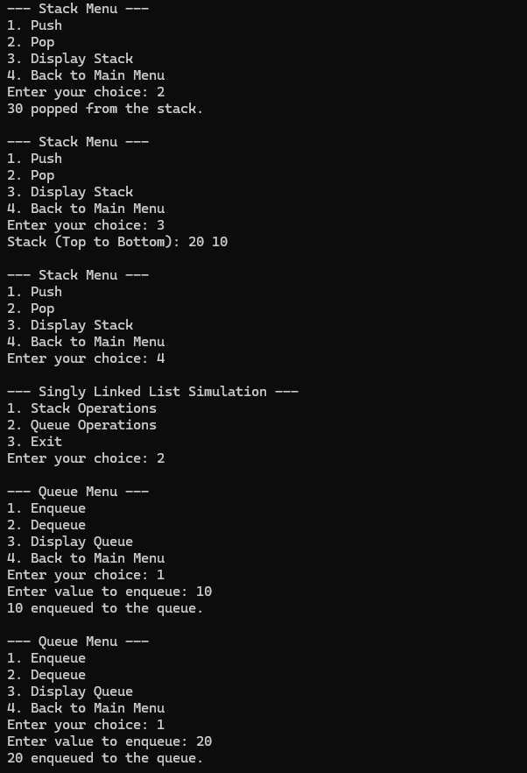

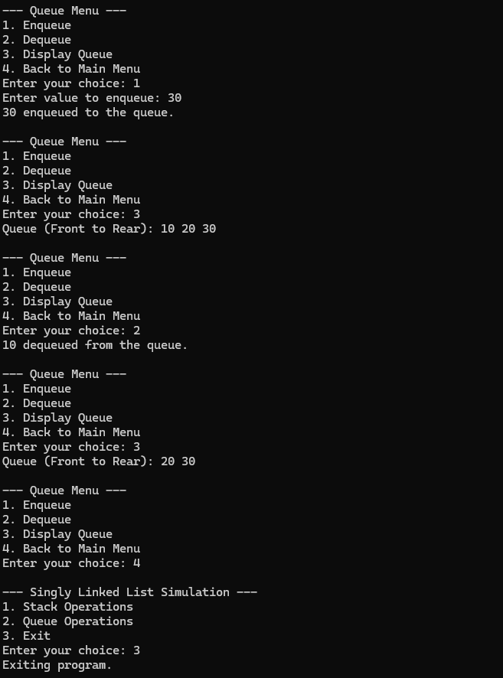

Lab program 7a:
WAP to Implement doubly link list with primitive operations
a) Create a doubly linked list.
b) Insert a new node to the left of the node.
c) Delete the node based on a specific value
d) Display the contents of the list

#include <stdio.h>
#include <stdlib.h>

struct Node {
int data;
struct Node *prev;
struct Node *next;
};

struct Node *head = NULL, *tail = NULL;

void createList(int n) {
int value;
struct Node *newNode;

for(int i = 0; i < n; i++) {
printf("Enter data for node %d: ", i+1);
scanf("%d", &value);

newNode = (struct Node*)malloc(sizeof(struct Node));
newNode->data = value;
newNode->prev = newNode->next = NULL;

if (head == NULL) {
head = tail = newNode;
} else {
tail->next = newNode;
newNode->prev = tail;
tail = newNode;
}
}
}

void insertAtFront(int data) {
struct Node *newNode = (struct Node*)malloc(sizeof(struct Node));
newNode->data = data;
newNode->prev = NULL;
newNode->next = head;

if (head == NULL)
head = tail = newNode;
else {
head->prev = newNode;
head = newNode;
}
}

void insertAtEnd(int data){
struct Node *newNode = (struct Node*)malloc(sizeof(struct Node));
newNode->data = data;
newNode->next = NULL;
newNode->prev = tail;

if (tail == NULL)
head = tail = newNode;
else{
tail->next = newNode;
tail = newNode;
}
}

void insertAtPosition(int data, int pos){
int i;
struct Node *newNode, *temp = head;

if (pos == 1) {
insertAtFront(data);
return;
}

newNode = (struct Node*)malloc(sizeof(struct Node));
newNode->data = data;

for (i=1; i<pos-1 && temp!= NULL; i++)
temp = temp->next;

if(temp == NULL || temp->next == NULL) {
insertAtEnd(data);
return;
}

newNode->next = temp->next;
newNode->prev = temp;
temp->next->prev = newNode;
temp->next = newNode;
}

void deleteAtFront() {
if (head == NULL) {
printf("List is empty!\n");
return;
}

struct Node *temp = head;
head = head->next;

if (head != NULL)
head->prev = NULL;
else
tail = NULL;

free(temp);
}

void deleteAtEnd() {
if (tail == NULL) {
printf("List is empty!\n");
return;
}

struct Node *temp = tail;
tail = tail->prev;

if (tail != NULL)
tail->next = NULL;
else
head = NULL;

free(temp);
}

void deleteByValue(int value) {
struct Node *temp = head;

while (temp != NULL && temp->data != value)
temp = temp->next;

if (temp == NULL) {
printf("Value not found!\n");
return;
}

if (temp == head)
deleteAtFront();
else if (temp == tail)
deleteAtEnd();
else {
temp->prev->next = temp->next;
temp->next->prev = temp->prev;
free(temp);
}
}

void deleteByPosition(int pos) {
if (head == NULL) {
printf("List is empty!\n");
return;
}

if (pos <= 0) {
printf("Invalid position!\n");
return;
}

struct Node *temp = head;
int i;

// Case 1: Delete first node
if (pos == 1) {
deleteAtFront();
return;
}

// Move to the (pos)-th node
for (i = 1; i < pos && temp != NULL; i++) {
temp = temp->next;
}

if (temp == NULL) {
printf("Position out of range!\n");
return;
}

// Case 2: Delete last node
if (temp == tail) {
deleteAtEnd();
return;
}

// Case 3: Delete node in the middle
temp->prev->next = temp->next;
temp->next->prev = temp->prev;

free(temp);
}
void display() {
struct Node *temp = head;
printf("List: ");

while (temp != NULL) {
printf("%d <-> ", temp->data);
temp = temp->next;
}
printf("NULL\n");
}

int main()
{
int choice, n, data, pos;

while(1)
{
printf("\n--- Doubly Linked List Operations ---\n");
printf("1. Create Doubly Linked List\n");
printf("2. Insert at Front\n");
printf("3. Insert at Any Position\n");
printf("4. Insert at End\n");
printf("5. Delete First Element\n");
printf("6. Delete Specific Element\n");
printf("7. Delete Last Element\n");
printf("8. Display List\n");
printf("9. Delete By Position\n");
printf("10. Exit\n");
printf("Enter your choice:");
scanf("%d", &choice);

switch (choice)
{
case 1:
printf("Enter number of nodes: ");
scanf("%d", &n);
createList(n);
printf("List Created Successfully.");
break;

case 2:
printf("Enter data to insert: ");
scanf("%d", &data);
insertAtFront(data);
break;

case 3:
printf("Enter data and position: ");
scanf("%d %d", &data, &pos);
insertAtPosition(data, pos);
break;

case 4:
printf("Enter data to insert: ");
scanf("%d", &data);
insertAtEnd(data);
break;

case 5:
deleteAtFront();
break;

case 6:
printf("Enter value to delete: ");
scanf("%d", &data);
deleteByValue(data);
break;

case 7:
deleteAtEnd();
break;

case 8:
display();
break;

case 9:
printf("Enter position to delete: ");
scanf("%d", &pos);
deleteByPosition(pos);
printf("Deleted position: %d", pos);
break;

case 10:
printf("Exiting...\n");
exit(0);

default:
printf("Invalid choice. Try again.\n");
}
}
return 0;
}

Output:
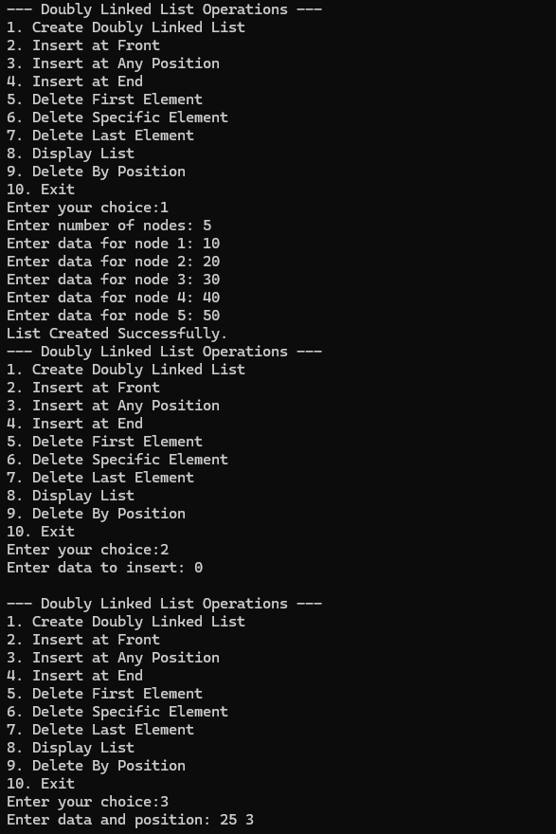
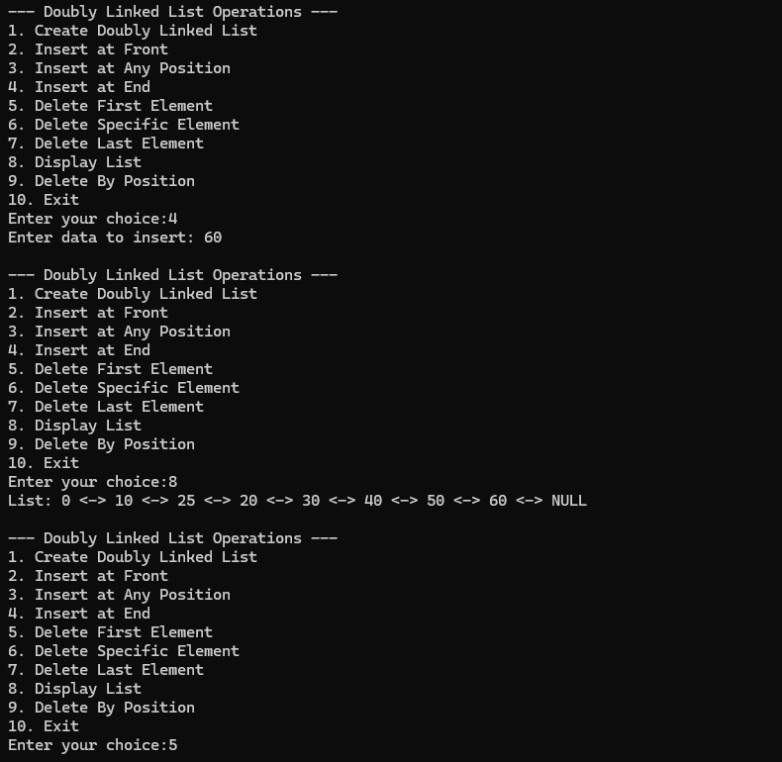
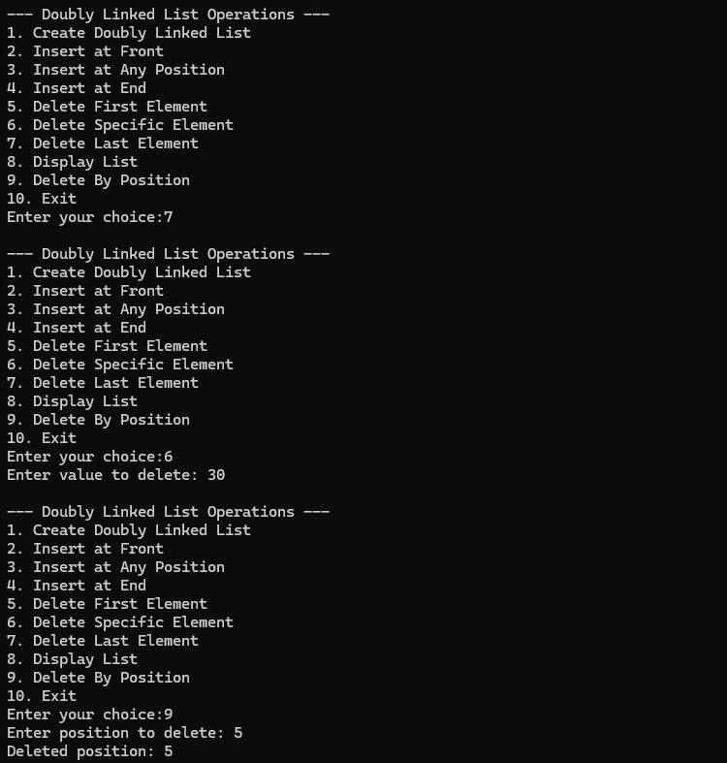
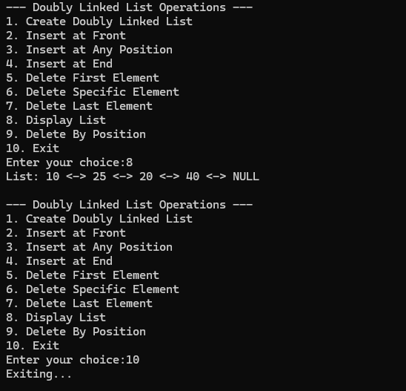

Lab program 7b:
Program - Leetcode platform
/**
* Definition for singly-linked list.
* struct ListNode {
* int val;
* struct ListNode *next;
* };
*/
bool hasCycle(struct ListNode *head) {
if (head == NULL || head->next == NULL)
return false;

struct ListNode *slow = head;
struct ListNode *fast = head;

while (fast != NULL && fast->next != NULL) {
slow = slow->next;
fast = fast->next->next;

if (slow == fast)
return true;
}

return false;

}

Output:
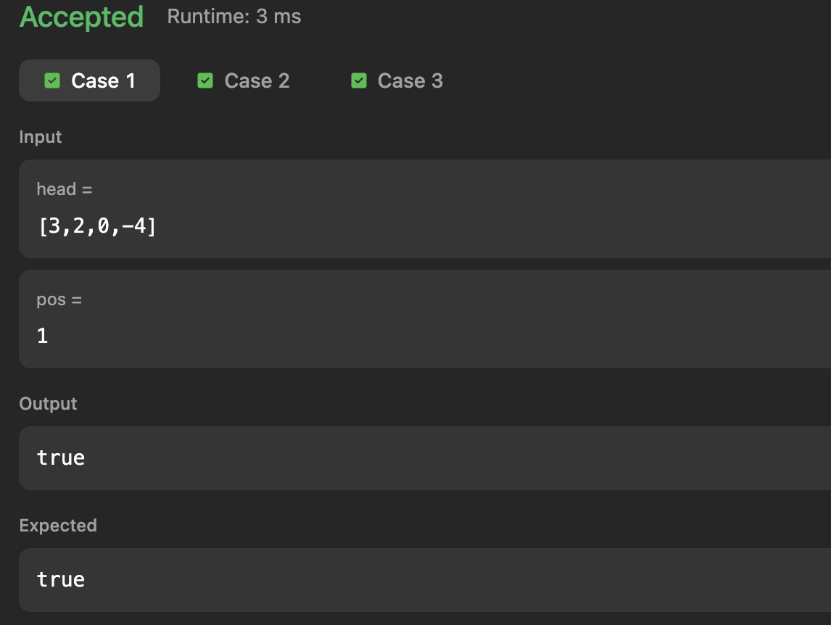
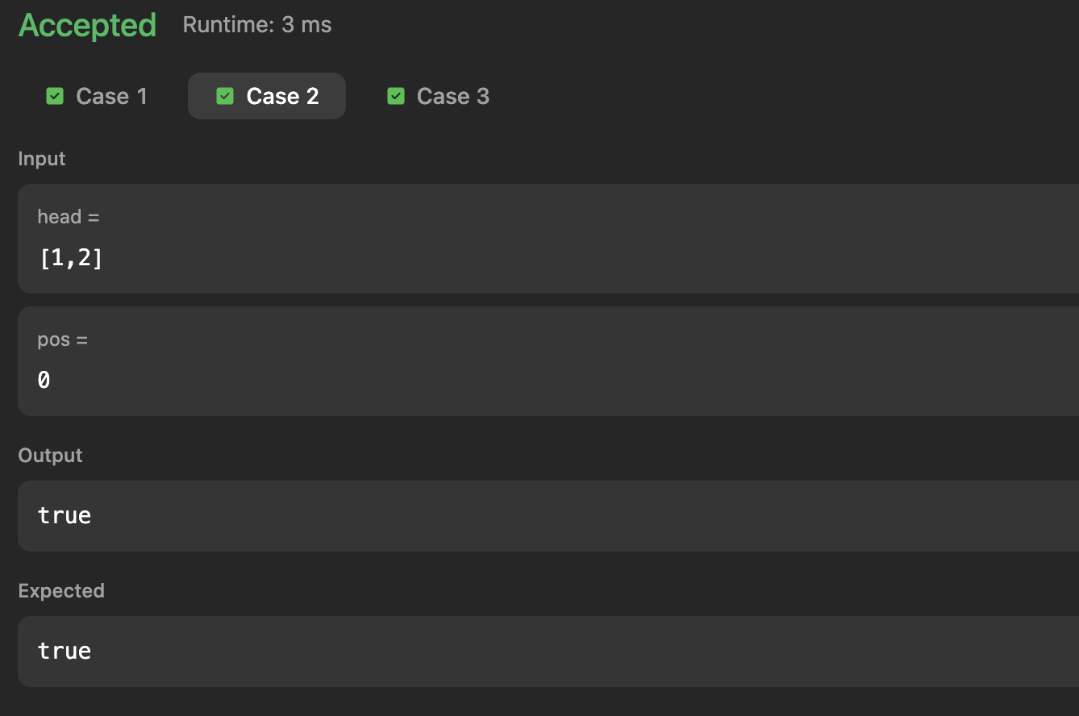
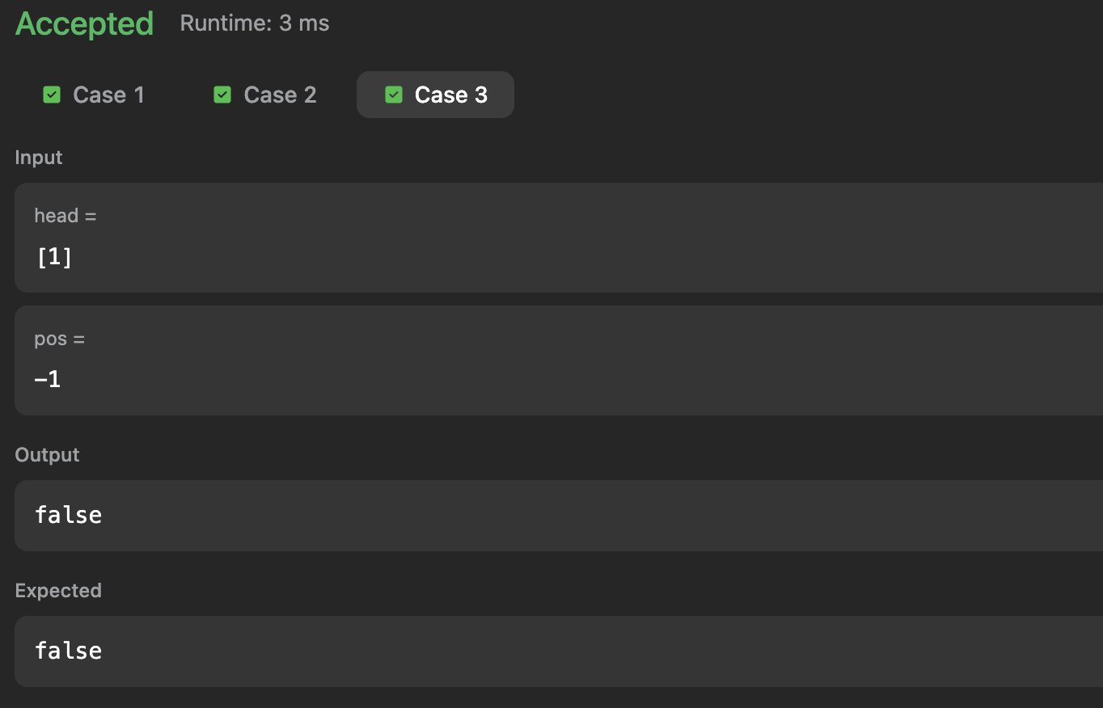

Lab program 8a:
Write a program
a) To construct a binary search tree.
b) To traverse the tree using all the methods i.e., in-order, preorder and post order
c) To display the elements in the tree.

#include <stdio.h>
#include <stdlib.h>

struct Node {
int data;
struct Node *left, *right;
};

struct Node* createNode(int value) {
struct Node *newNode = (struct Node*)malloc(sizeof(struct Node));
newNode->data = value;
newNode->left = newNode->right = NULL;
return newNode;
}

struct Node* insert(struct Node *root, int value) {
if (root == NULL)
return createNode(value);

if (value < root->data)
root->left = insert(root->left, value);
else if (value > root->data)
root->right = insert(root->right, value);

return root;
}

void inorder(struct Node *root) {
if (root == NULL) return;
inorder(root->left);
printf("%d ", root->data);
inorder(root->right);
}

void preorder(struct Node *root) {
if (root == NULL) return;
printf("%d ", root->data);
preorder(root->left);
preorder(root->right);
}

void postorder(struct Node *root) {
if (root == NULL) return;
postorder(root->left);
postorder(root->right);
printf("%d ", root->data);
}

void display(struct Node *root) {
printf("BST Elements (Inorder): ");
inorder(root);
printf("\n");
}

int main() {
struct Node *root = NULL;
int choice, value;

while (1) {
printf("\n--- Binary Search Tree Menu ---\n");
printf("1. Insert into BST\n");
printf("2. Inorder Traversal\n");
printf("3. Preorder Traversal\n");
printf("4. Postorder Traversal\n");
printf("5. Display BST\n");
printf("6. Exit\n");
printf("Enter choice: ");
scanf("%d", &choice);

switch (choice) {
case 1:
printf("Enter value to insert: ");
scanf("%d", &value);
root = insert(root, value);
break;

case 2:
printf("Inorder Traversal: ");
inorder(root);
printf("\n");
break;

case 3:
printf("Preorder Traversal: ");
preorder(root);
printf("\n");
break;

case 4:
printf("Postorder Traversal: ");
postorder(root);
printf("\n");
break;

case 5:
display(root);
break;

case 6:
exit(0);

default:
printf("Invalid choice! Try again.\n");
}

}

return 0;
}
Output:
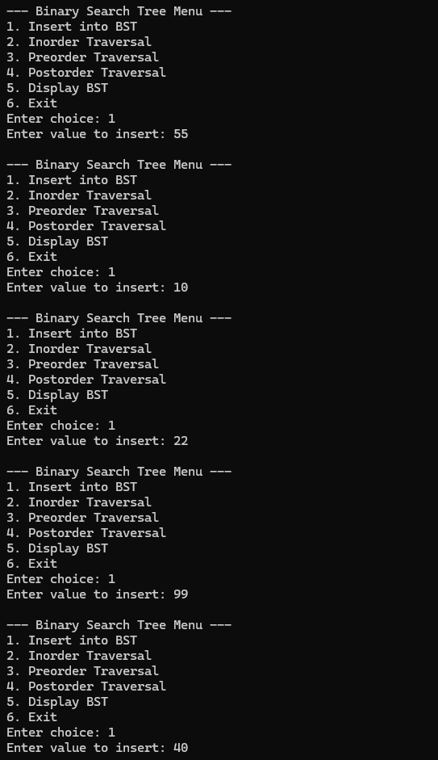
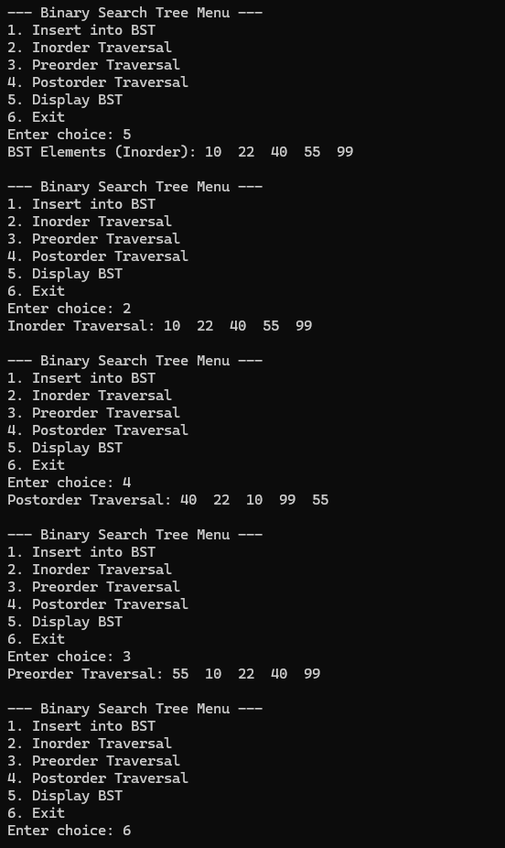
Lab program 8b:
Program - Leetcode platform

/**
* Definition for a binary tree node.
*/

struct TreeNode* mergeTrees(struct TreeNode* root1, struct TreeNode* root2) {
// If both trees are empty
if (root1 == NULL && root2 == NULL)
return NULL;

// If one of the trees is empty, return the other
if (root1 == NULL)
return root2;
if (root2 == NULL)
return root1;

// Both nodes exist → add values
root1->val = root1->val + root2->val;

// Recursively merge left and right subtrees
root1->left = mergeTrees(root1->left, root2->left);
root1->right = mergeTrees(root1->right, root2->right);

return root1;
}

Output:
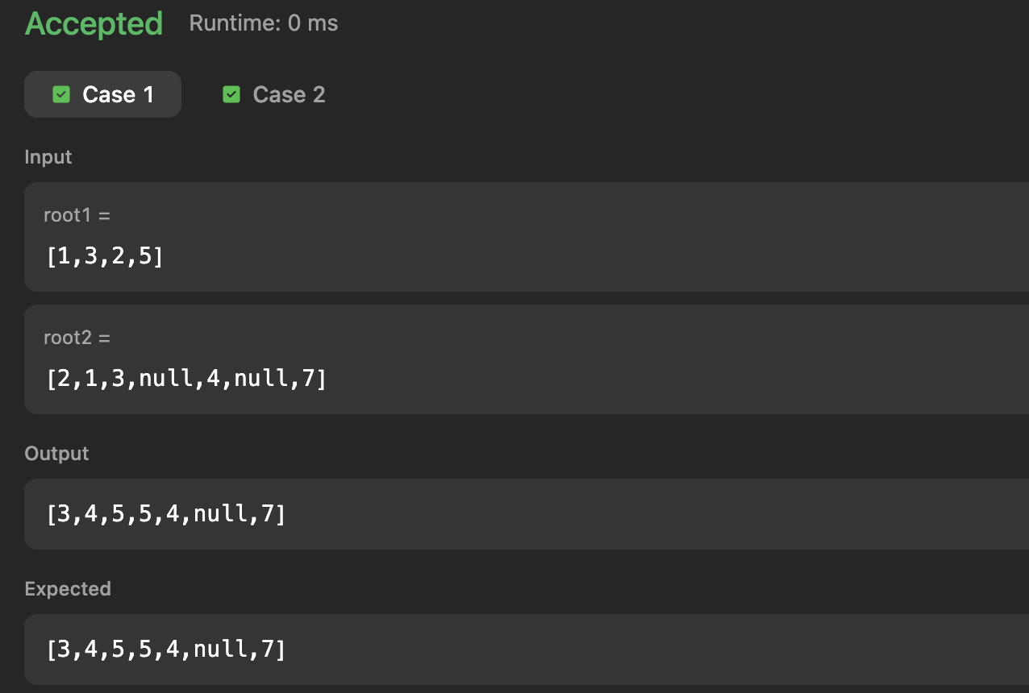
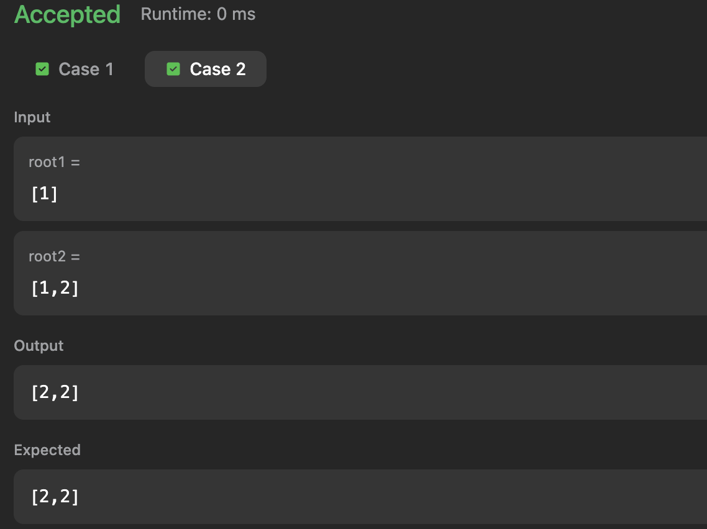

Lab program 9a:
a) Write a program to traverse a graph using the BFS method.
#include <stdio.h>

int graph[20][20], visited[20], n;

void BFS(int start)
{
int queue[20];
int front = 0, rear = 0;

visited[start] = 1;
queue[rear++] = start;

while (front < rear)
{
int node = queue[front++];

printf("%d ", node);

for (int i = 0; i < n; i++)
{
if (graph[node][i] == 1 && !visited[i])
{
visited[i] = 1;
queue[rear++] = i;
}
}
}
}

int main()
{
int start;

printf("Enter number of vertices: ");
scanf("%d", &n);

printf("Enter adjacency matrix:\n");
for (int i = 0; i < n; i++)
{
for (int j = 0; j < n; j++)
{
scanf("%d", &graph[i][j]);
}
}

for (int i = 0; i < n; i++)
{
visited[i] = 0;
}

printf("Enter starting vertex: ");
scanf("%d", &start);

printf("BFS Traversal: ");
BFS(start);

return 0;
}

Output:
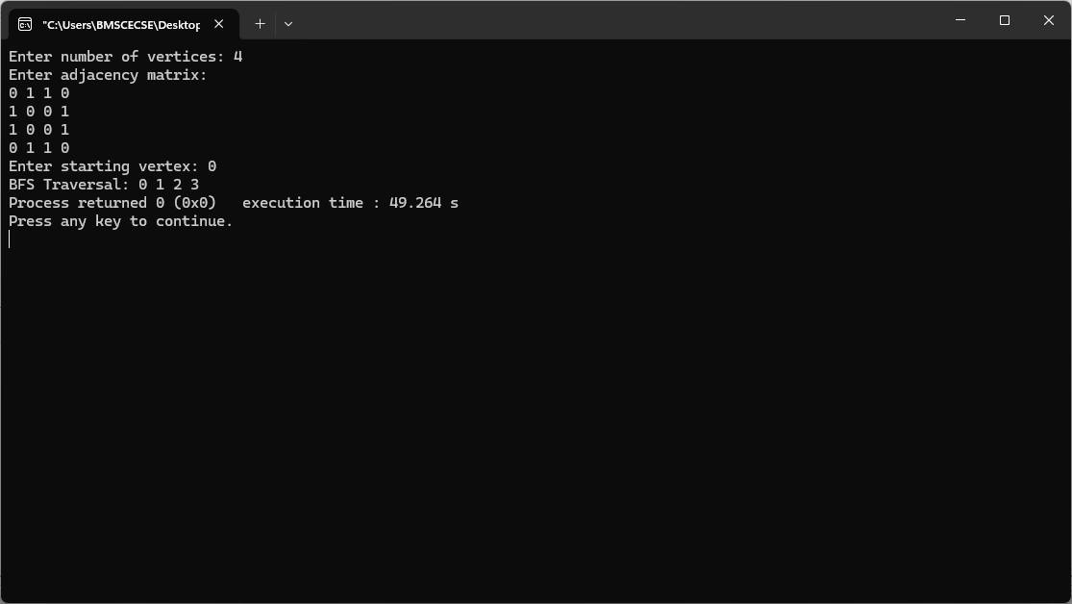

Lab program 9b:
b) Write a program to check whether a given graph is connected or not using the DFS method.

#include <stdio.h>
#define MAX 20

int adj[MAX][MAX];
int visited[MAX];
int n;

void DFS(int v)
{
visited[v] = 1;

for (int i = 0; i < n; i++)
{
if (adj[v][i] == 1 && !visited[i])
{
DFS(i);
}
}
}

int main()
{
int connected = 1;

printf("Enter number of vertices: ");
scanf("%d", &n);

printf("Enter adjacency matrix:\n");
for (int i = 0; i < n; i++)
{
for (int j = 0; j < n; j++)
{
scanf("%d", &adj[i][j]);
}
}

for (int i = 0; i < n; i++)
{
visited[i] = 0;
}

DFS(0);

for (int i = 0; i < n; i++)
{
if (!visited[i])
{
connected = 0;
break;
}
}

if (connected)
printf("The graph is CONNECTED.\n");
else
printf("The graph is NOT CONNECTED.\n");

return 0;
}
Output:
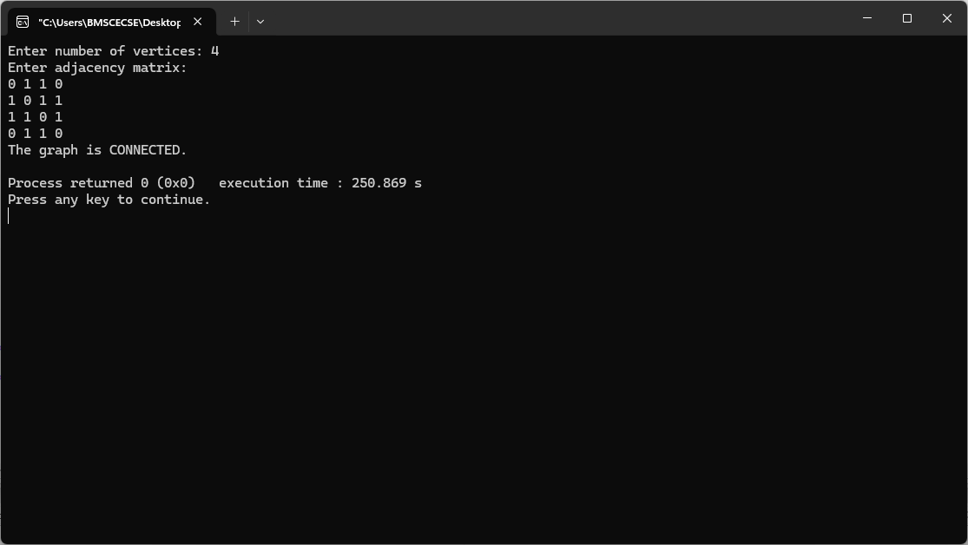
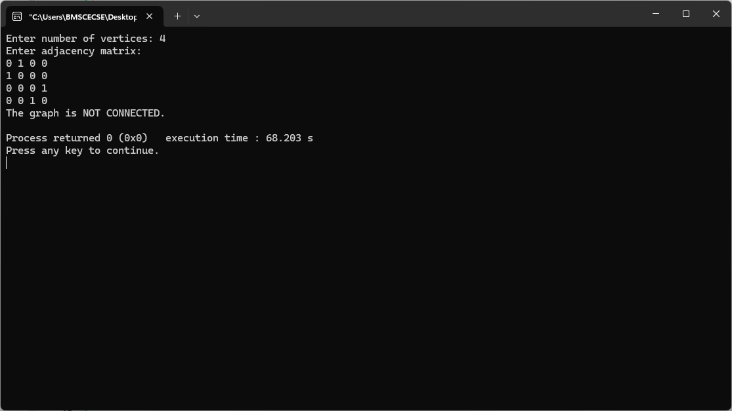

Lab program 10:
Given a File of N employee records with a set K of Keys(4-digit) which uniquely determine the records in file F. Assume that file F is maintained in memory by a Hash Table (HT) of m memory locations with L as the set of memory addresses (2-digit) of locations in HT. Let the keys in K and addresses in L are integers.Design and develop a Program in C that uses Hash function H: K -> L as H(K)=K mod m (remainder method), and implement hashing technique to map a given key K to the address space L. Resolve the collision (if any) using linear probing.

#include <stdio.h>
#define MAX 20
int hashTable[MAX];
int m;
void insert(int key)
{
int index = key % m;
if (hashTable[index] == -1)
{
hashTable[index] = key;
}
else
{
int i = 1;
while (hashTable[(index + i) % m] != -1)
{
i++;
}
hashTable[(index + i) % m] = key;
}
}
void display()
{
printf("\nHash Table:\n");
for (int i = 0; i < m; i++)
{
if (hashTable[i] != -1)
printf("Address %d : %d\n", i, hashTable[i]);
else
printf("Address %d : Empty\n", i);
}
}
int main()
{
int n, key;
printf("Enter size of hash table (m): ");
scanf("%d", &m);
printf("Enter number of keys: ");
scanf("%d", &n);

for (int i = 0; i < m; i++)
hashTable[i] = -1;
printf("Enter %d keys:\n", n);
for (int i = 0; i < n; i++)
{
scanf("%d", &key);
insert(key);
}
display();
return 0;
}

Output:

